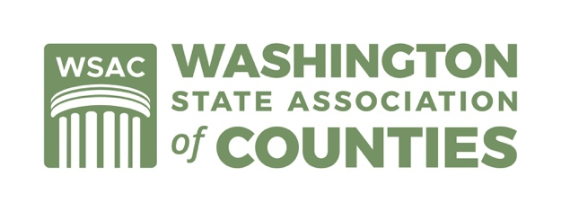

National County Government Month - April 2022
Sample Proclamation

WHEREAS, Washington’s 39 counties serving more than 7.5 million residents provide essential services to create healthy, safe and vibrant communities; and

WHEREAS, counties provide health services, administer justice, keep communities safe, foster economic opportunities and much more; and

WHEREAS, [INSERT YOUR COUNTY’S NAME] and all counties take pride in our responsibility to protect and enhance the health, welfare and safety of our residents in efficient and cost-effective ways; and

WHEREAS, through the Washington State Association of Counties and the National Association of Counties across the nation, counties will be demonstrating the beauty of our state, it’s people, and how counties deliver services to our residents nationwide; and

WHEREAS, each year since 1991 the Washington State Association of Counties and the National Association of Counties has encouraged counties across the country to elevate awareness of county responsibilities, programs and services; and

WHEREAS, [INSERT COUNTY SPECIFIC INFO TO HIGHLIGHT]

NOW, THEREFORE, BE IT RESOLVED THAT, [INSERT YOUR COUNTY’S NAME AND BOARD], do hereby proclaim April 2022 as National County Government Month and encourage all county officials, employees, schools and residents to participate in county government celebration activities.

FOR MORE INFORMATION, PLEASE CONTACT:

Eric Johnson
Executive Director, Washington State Association of Counties
360.489.3020 | ejohnson@wsac.org www.wsac.org

